# Module 10: Investigating Web Attacks Screenshots

Lara Alofi

2110886

Y

Computer Hacking Forensic Investigator (CHFI)

Lab Session Identifiers

1. <https://labclient.labondemand.com/LabClient/993f8857-e6ac-4714-b472-25e638b74c48>

Username on EC-Council System

1. 2110886@uj.edu.sa

Lab 01

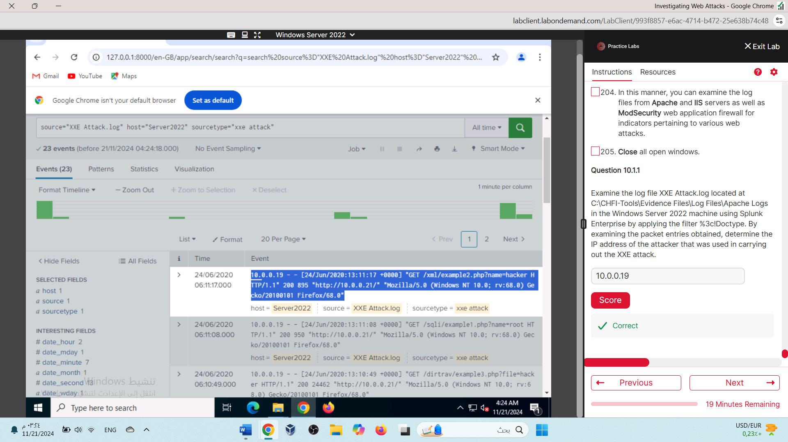

Lab 02



